Cancelled Planned Operations

Month Ending 31 March 2019

Official Statistics publication for Scotland

Publication Date: 7 May 2019

RESTRICTED STATISTICS: embargoed to 09:30 07/05/2019

About this release

This release by Information Services Division (ISD) provides a monthly update on the number of patients in NHSScotland who have had their planned hospital operation cancelled the day before, or on the day of their planned operation and the reason for this cancellation.

Main points

* The total number of planned operations across NHSScotland during March 2019 was 21,603, a decrease of 25.6% from 29,045 during March 2018.
* 1,987 operations (9.2% of all planned operations) were cancelled in March 2019, ranging from 5.2% to 14.3% across individual NHS Boards. This compares to 3,646 (12.6%) in March 2018.
* In March 2019, of all 21,603 planned operations: 716 (3.3%) were cancelled by the patient; 656 (3%) were cancelled by the hospital based on clinical reasons; 508 (2.4%) were cancelled by the hospital due to capacity or non-clinical reasons; 107 (0.5%) were cancelled due to other reasons.

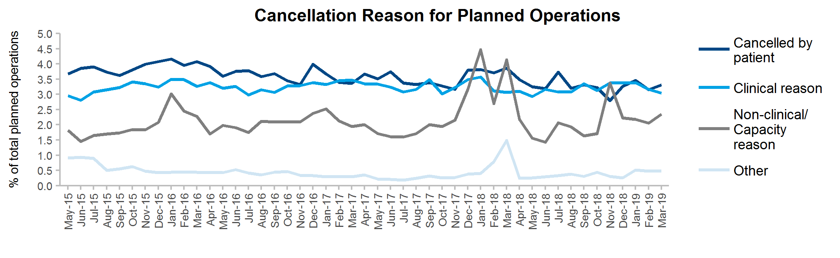

* The peak in cancellations for non-clinical/capacity reasons in November 2018 (3.4%) relates to the unplanned, temporary closure of the Cowlairs decontamination unit in NHS Greater Glasgow & Clyde. The spikes in March 2018 for non-clinical/capacity reasons (4.1%) and other reasons (1.5%) were due to poor weather affecting patient and staff travel.

Background

These statistics are released monthly. Data for this publication are submitted from NHS Board theatre systems.

Contact

|  |  |
| --- | --- |
| **Amye Thomson** | **Adam Rennie** |
| Senior Information Analyst | Information Analyst |
| 0141 207 1894 | 0141 282 2064 |

General Enquiries

[nss.isdwaitingtimes@nhs.net](mailto:nss.isdwaitingtimes@nhs.net)

Further Information

A [workbook](http://isdscotland.org/Health-Topics/Waiting-Times/Publications/2019-05-07/2019-05-07-Cancellations.xlsx) containing data for Scotland, NHS Boards and hospitals is available.

Further information can be found on the [waiting times](http://www.isdscotland.org/Health-Topics/Waiting-Times/) pages of the ISD website. A [metadata document](http://isdscotland.org/Health-Topics/Waiting-Times/Publications/2019-05-07/2019-05-07-Cancellations-metadata.pdf) has been produced for this publication.

The next release of this publication will be June 2019

NHS Performs

A selection of information from this publication is included in [NHS Performs](http://www.nhsperforms.scot/). NHS Performs is a website that brings together a range of information on how hospitals and NHS Boards within NHSScotland are performing.